BUSINESS INSIGHTS FROM THE PROJECT:
The cleaned dataset generated a total revenue of 10.67 million (10666684.544) monetary units from valid sales transactions.
There were:
Number of unique transactions made 19962
Number of Unique Products Sold:3922
Number of Unique Customers who made purchases.
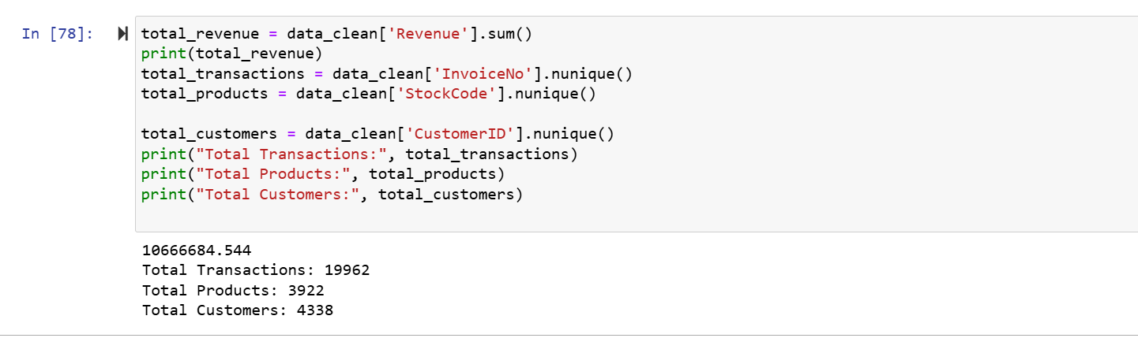

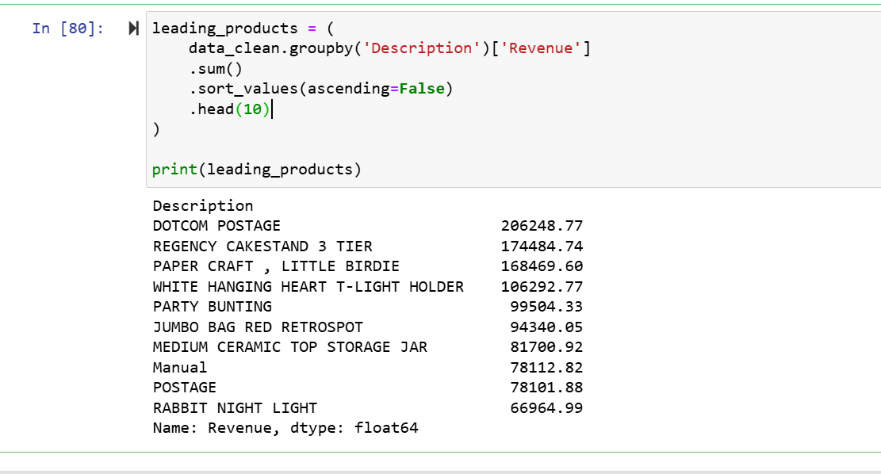

Analysis of product revenue revealed that the highest-performing products contributed a substantial portion of total sales revenue. The top 10 products generated significantly more revenue than the rest of the catalogue, indicating that the business relies heavily on a small group of high-performing products.
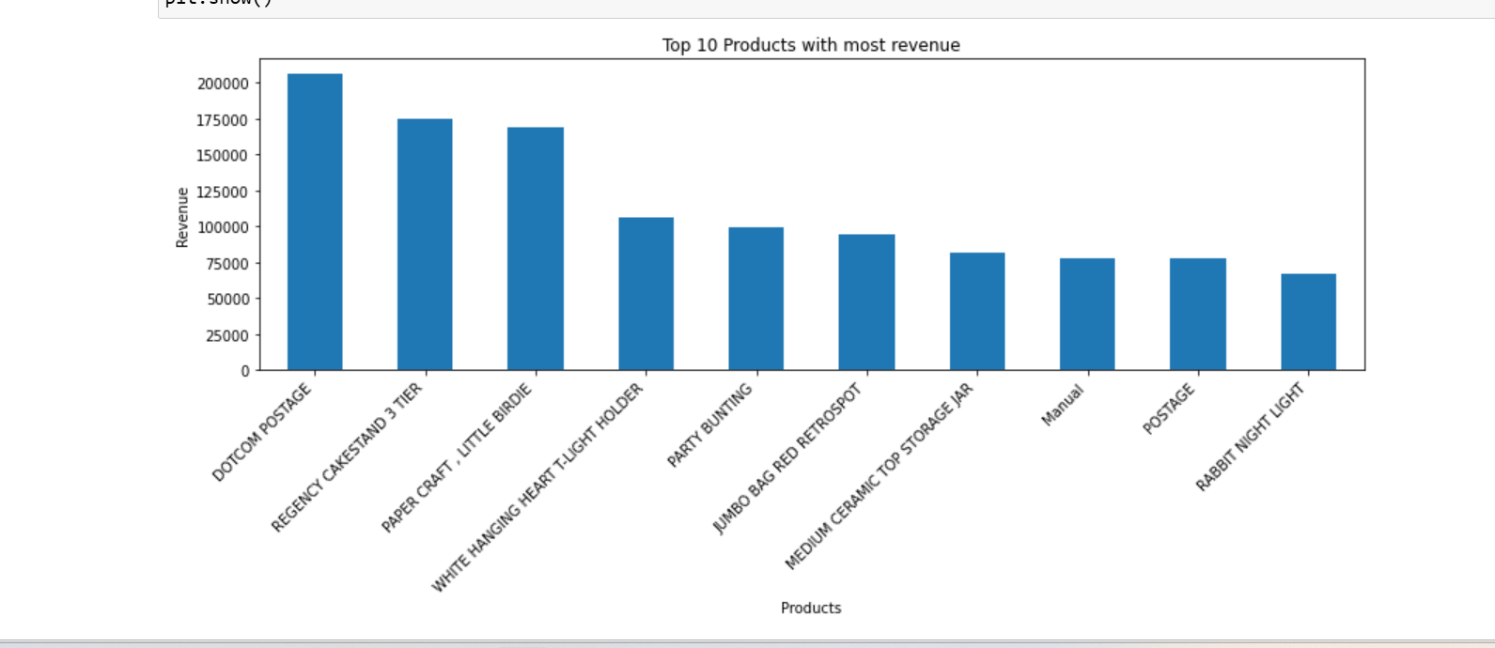

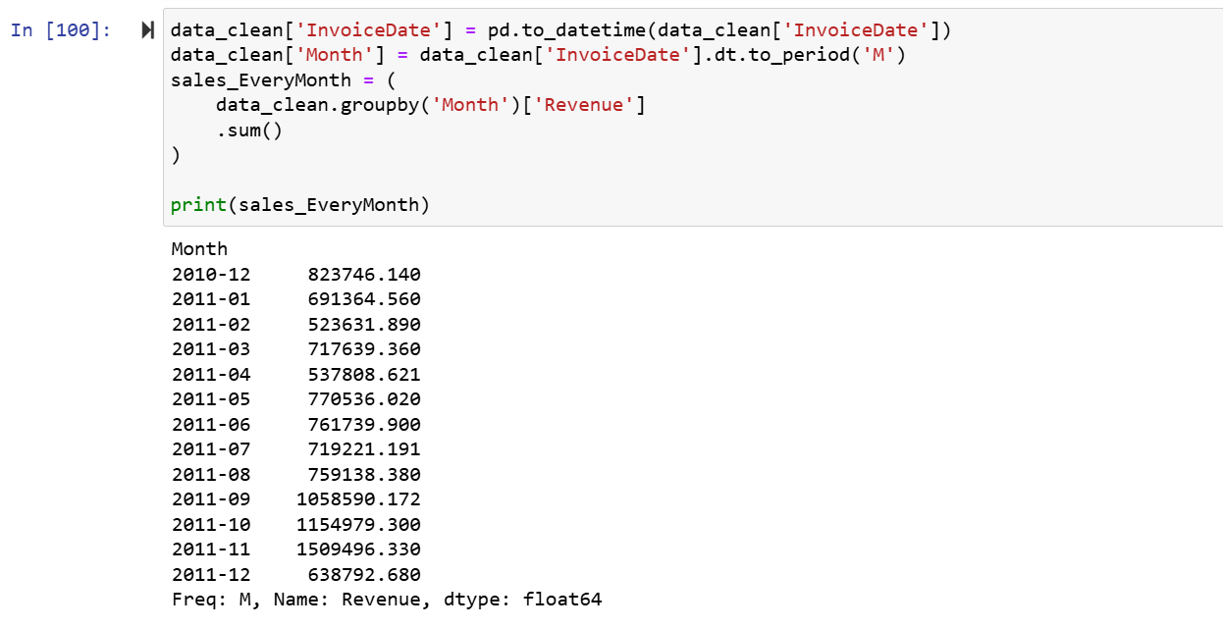

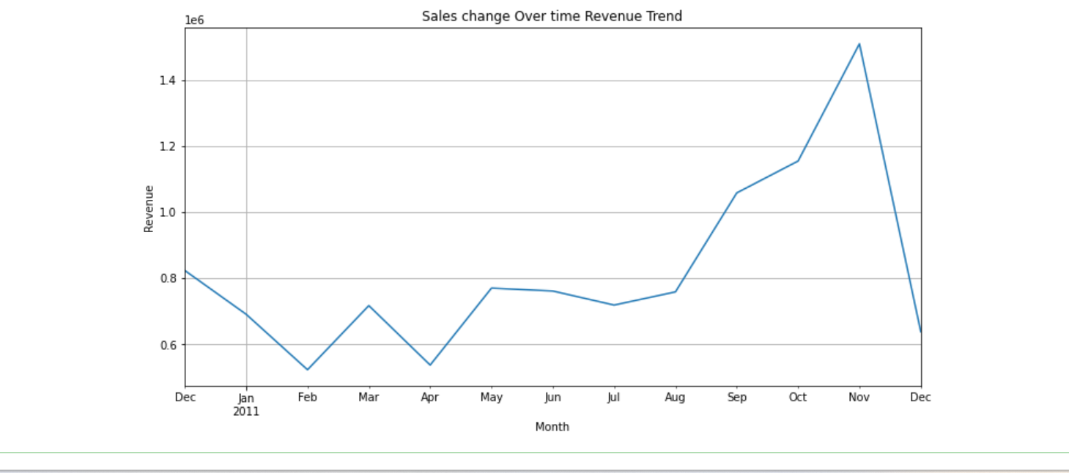
Monthly revenue analysis shows that sales increased steadily throughout the year, with the highest revenue recorded in November. This suggests strong seasonal demand during the holiday shopping period.

